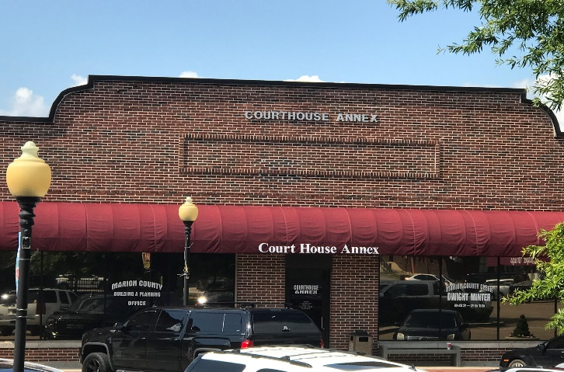
Courthouse Annex
24 Courthouse Square, Minter Building, Suite 105 Jasper, TN 37347
Mailing Address: PO Box 789 Jasper, TN 37347

Office Hours: Monday through Friday 8:00 A.M. - 4:00 P.M. CST
Closed for lunch: 1:00 – 2:00 P.M. CST

Marion County Building
Gabe Yeargan, Building Official
Phone: 423 942 8019
Email: gyeargan@marioncountytn.net

Marion County Regional Planner
Ashley Gates, Senior Regional Planner
Southeast Tennessee Development District
1000 Riverfront Parkway, Chattanooga, TN 37402
Phone: 423 424 4218
Email: agates@sedev.org

Marion County Planning Administrative Staff
Renea Wilson
Phone: 423 942 3527
Email: rwilson@marioncountytn.net

Marion County Attorney
William Gouger
PO Box 759
Jasper, TN 37347
Phone: 423 942 9975
Email: bgouger@CGCRTA.COM

