To: Marion County Regional Planning Commission and Marion County Planning Commission Files
From: Renea Wilson
Date: November 7, 2023
Subject: Minutes for the October 3, 2023, Marion County Regional Planning Commission
Meeting held at 4:00 P.M., at the Lawson Building

Members Present
Keith Garth
Gene Hargis, Marion County Commissioner, District 2, Seat B, Co-Chairman
Mayor David Jackson, Marion County Mayor, Chairman
Cory Pickett, Marion County Road Superintendent
Chris Morrison, Marion County Commissioner, District 5, Seat C
Louise Powell, Secretary
Jimmy Sneed

Members Absent
Robert Kelly - Vacation
Johnny Rogers

Staff
Ashley Gates, Senior Regional Planner, SETDD, Chattanooga
William ‘Billy’ Gouger, Marion County Attorney

Others
Jeff Elliott/Elliott Surveying
Clarence Howard, SR. V.P. of Construction, Thunder Air Inc
Dane Bradshaw

Mayor Jackson, called the regular monthly Marion County Planning Commission meeting to order at 4:00 P.M.

- Invocation Commissioner Hargis
- Pledge of Allegiance Commissioner Morrison
- Roll Call Renea Wilson

A motion was made to approve the September 5, 2023 Planning Commission Meeting Minutes as presented.

Motion By: Commissioner Morrison
2nd: Commissioner Hargis
Vote: All MCRP members voting “Aye”

Old Business

Building Permit Report

September 2023
37 Permits issued – Value - $4,520,883.00

- four million five hundred twenty thousand eight hundred eighty-three dollars

Staff Approved Plats Report

There were 7 Staff Approved Plats for September 2023

Irrevocable Letters of Credit and/or Bonds Report
There is a change to this report since your last MCRP meeting September 5, 2023.

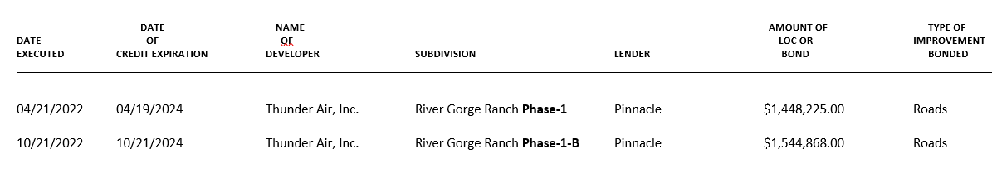
River Gorge Ranch Phase 1-B $1,544,868.00. This is a self-renewing Letter of Credit which means it automatically renews annually on its anniversary date unless the County Planning Commission receives notice by certified mail at least ninety (90) days prior to its expiration date that the bank intends not to renew.

DATE OF CREDIT EXPIRATION modified from 10/21/2023 to 10/21/2024 as no notice has been received from the bank that they do not intend to renew this Letter of Credit.

New Business

- Plat Title: Final Plat Scott Floyd Subdivision
Surveyor: Jeff Elliott/Elliott Land Surveying
Property Owner(s): John Floyd Jr.
Property Address: 281 Worley Lane
Parcel ID Number(s): 012 001.01
Analysis: This plat creates a 0.64-acre lot, with 8+ acres remaining in the tract. The lot has frontage on Worley Lane, a county-maintained road. Public water is said to be available and wastewater disposal will be by existing septic.
The new lot reduces the road frontage of the remaining 8+ acres to a 41-foot flag stem, less than the 50-foot minimum.

Staff (Senior Planner, Ashley Gates) recommends a variance to the minimum flag stem width.

Variance: Flag Stem variance to 41.11’ and not the minimum 50-foot minimum flag stem width.

Variance Approval
Motion By: Louise Powell
2nd: Commissioner Hargis
Vote: All MCRP members voting “Aye”

Final Plat Approval

Subject to all signatures on all plat copies

Motion By: Louise Powell
2nd: Keith Garth
Vote: All MCRP members voting “Aye”

- Plat Title: Final Plat River Gorge Ranch – Phase 2 – Lots 2035-2072 and 2219 - 2228
Surveyor: Jeff Elliott/Elliott Land Surveying
Property Owner(s): Thunder Air, Inc.

Ashely Gates: Mr. Elliott submitted all of the corrections to me earlier today and they appear to have all been made. There was one thing the centerlines are a requirement for your Final Plat, and they are not on here. They were on the Road Plans. In the future they should be shown on both the Road Plans and the Final Plat since it is listed as a requirement in the regulations.
I recommend approval contingent on Mr. Pickett’s (Road Superintendent) recommendations and Mr. Gouger’s recommendations regarding the Performance Guarantee and the Road Plans as well as some kind of notation regarding the drainage easement. If you remember last month TDEC has an issue with our drainage easement being shown on the plat so there need to be a note in the record.
Attorney Gouger: Historically, all lot lines were subject to drainage and utility easements. I guess that has become a problem for TDEC. I guess they think you are going to put drainage somewhere they don’t approve of.
Jeff Elliott: It interferes with the field lines is what TDEC says.
Clarence Howard: Does not affect the utility easement just the drainage easement.
Attorney Gouger: Notation to the minutes showing that this Final Plat is approved subject to that there are drainage easements along the lot lines if needed.

Final Plat Approval

Subject to all signatures on all plat copies

Motion By: Louise Powell
2nd: Commissioner Morrison
Vote: All MCRP members voting “Aye”

Road Design Profiles Approval

Road Design Profiles: River Gorge Ranch- Phase 2 -Lots 2035 – 2072 and 2219 - 2228
Surveyor: Jeff Elliott/Elliott Surveying
Property Owner(s): Thunder Air, Inc.

Cory Picket: I’m O.K. with it. The roads depicted on this plat are sufficiently covered under the current performance guarantee.

Other
Mayor Jackson: Is there any public comment to anything that was on this meeting agenda only?

Our next meeting is Tuesday, November 7, 2023

Adjournment

Motion By: Commissioner Hargis
2nd: Commissioner Morrison
Vote: All MCRP members voting “Aye”

