To: Marion County Regional Planning Commission and Marion County Planning Commission Files
From: Renea Wilson
Date: October 3, 2023
Subject: Minutes for the September 5, 2023, Marion County Regional Planning Commission
Meeting held at 4:00 P.M., at the Lawson Building

Members Present
Keith Garth
Gene Hargis, Marion County Commissioner, District 2, Seat B, Co-Chairman
Mayor David Jackson, Marion County Mayor, Chairman
Robert Kelly
Cory Pickett, Marion County Road Superintendent
Chris Morrison, Marion County Commissioner, District 5, Seat C
Louise Powell, Secretary
Johnny Rogers
Jimmy Sneed

Members Absent
None

Staff
Ashley Gates, Senior Regional Planner, SETDD, Chattanooga
William ‘Billy’ Gouger, Marion County Attorney

Others
Hunter Bradford/B & H Surveying Services
Jeff Elliott/Elliott Surveying
Clarence Howard, SR. V.P. of Construction, Thunder Air Inc
Dane Bradshaw

Mayor Jackson, called the regular monthly Marion County Planning Commission meeting to order at 4:00 P.M.

- Invocation Commissioner Hargis
- Pledge of Allegiance Cory Pickett
- Roll Call Renea Wilson

A motion was made to approve the July 11, 2023 Planning Commission Meeting Minutes as presented.

Motion By: Commissioner Hargis
2nd: Commissioner Morrison
Vote: All MCRP members voting “Aye”

NOTE: The Marion County Regional Planning Commission meeting scheduled for August 1, 2023 was cancelled. All plats submitted in July were minor plats that were staff approved. There being no other agenda items that meeting was cancelled.

Old Business

Building Permit Report

July 2023
32 Permits issued – Value - $3,849,476.00
- three million eight hundred forty-nine thousand four hundred seventy-six dollars

August 2023
48 Permits issued – Value - $7,566,784.35
- seven million five hundred sixty-six thousand seven hundred eighty-four dollars and thirty-five cents

Staff Approved Plats Report

There were 7 Staff Approved Plats for July 2023
There were 4 Staff Approved Plats for August 2023

Irrevocable Letters of Credit and/or Bonds Report
There is a change to this report since your last MCRP meeting May 2, 2023.

The July 2023 Letter of Credit report reflects this commissions vote to release the LOC for Jasper Highlands Phase 5-B.
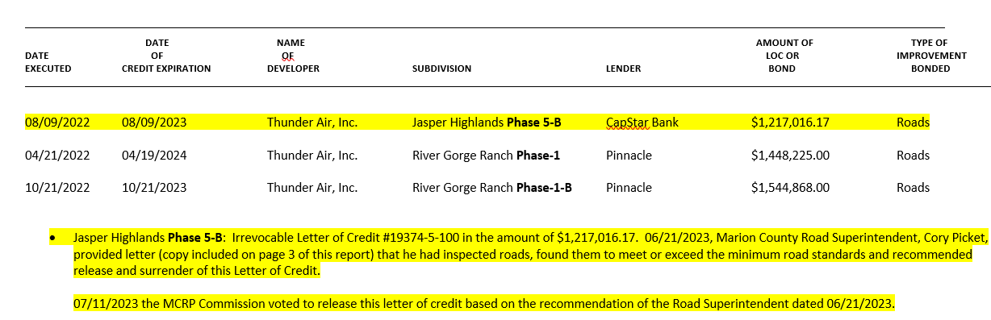

The August 2023 Letter of Credit report in in your meeting package simply removes the released LOC for Jasper Highlands Phase 5-B.

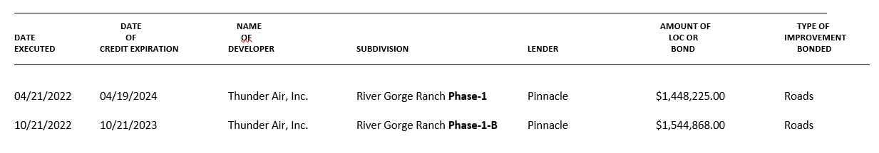

New Business

- Mayor Jackson

There is currently a proposal on a resolution for the Marion County Commission’s next meeting (September 25, 2023) to be presented to pay at large members that serve on committees.

Thank you for those of you that donate your time, we appreciate it. The commission (Marion County Commission) wants to pay you (proposed $75.00) per meeting. The County Attorney and I will be working on that resolution. Payment will be in the form of direct deposit.

- Louise Powell
Request from Assessor of Property, Darrell Pittman (dpittman2@marioncountytn.net) for electronic copies of Ashley’s Review of plats going forward.

Who will be responsible for providing the requested Plat Review copies to Mr. Pittman? Senior Regional Planner, Ashley Gates will provide those to Mr. Pittman electronically.

County Attorney Gouger advised this commission that no motion was needed for this request. Ashley will include Mr. Pittman on her reviews and Attorney Gouger will included Mr. Pittman on any communications that he is involved in.

CLARIFICATION:
Based on a conversation between Ashley and Darrell after the September 5, 2023 meeting, what Darrell is requesting are the CAD (Computer-Aided Design *a type of software*) files, which he uses to update the maps. Since the surveyors don’t usually send the CAD files to Ashley, Darrell asked to be copied on her reviews so that he knows to ask the surveyor for the CAD files.

- Plat Title: Final Plat Revised for Ashburn Property
Surveyor: Brain Bradford/B&H Surveying Services
Property Owner(s): Ama G. Ashburn; Rebecca Ball & Mark Puryear
Property Address: 118 Clark Grayson Drive/3085 Old Dunlap Road
Parcel ID Number(s): 028 052.00 & 053.00
Analysis: This plat reconfigures three existing parcels. Public water is said to be available and sewage disposal is by existing septic. The lots have access via Old Dunlap Road, a county-maintained road.

Final Plat Approval

Subject to all signatures on all plat copies

Motion By: Louise Powell
2nd: Commissioner Hargis
Vote: All MCRP members voting “Aye”

- Road Design Profiles: River Gorge Ranch
Phase 2
Lots 2001 – 2034 and 2229 - 2238
Surveyor: Jeff Elliott/Elliott Surveying
Property Owner(s): Thunder Air, Inc.

Ashley Gates: There was a variance that this commission approved on the initial Preliminary Plat. I am assuming that they will ask for the same on this plat as well.
Jeff Elliott: If it’s that tangent section I fixed it and made it 100 (one hundred) feet. It was only that one lot that was affected. I made it 100 (one hundred) feet tangent.
Ashley Gates: So, with that fixed there is no variance needed for that.
I did notice that in your Road Plans received last week that your gravel shoulder is only 2 (two feet) and the county standards call for 3 (three) feet.
Attorney Gouger: You all (Dane Bradshaw and Clarence Howard) are o.k. with it being amended to say 3 (three) feet on the shoulders?
Clarence Howard and Dane Bradshaw: Yes
Jeff Elliott: I will let Mike know to change it.
Attorney Gouger: The regs require 3 (three) feet gravel shoulders.
Mayor Jackson: So, this is an error (2 feet shoulders) on these printed copies and not something you are requesting.
Clarence Howard: 3 (three) feet, right.
Attorney Gouger: If those (Road Design Profiles) just need to be changed and marked on the profiles initialed and dated then that’s o.k. as long as these minutes reflect that change – 3 (three) feet shoulders NOT 2 (two) feet shoulders – has been approved by all parties (Clarence Howard and Dane Bradshaw) and the Planning Commission I think that will be fine. Is that alright with you Cory?
Cory Pickett: Yes
Ashley Gates: This approval comes at the recommendation of your Highway Superintendent.

Cory Picket: I’m O.K. with it.

Road Design Profiles Approval

Subject to the plans being marked to show 3 (three) feet gravel shoulders and not2 (two) feet gravel shoulders.

Subject to all signatures on all plat copies
Motion By: Louise Powell
2nd: Keith Garth
Vote: All MCRP members voting “Aye”

- Plat Title: Final Plat River Gorge Ranch
Phase 2
Lots 2001 – 2034 and 2229 - 2238
Surveyor: Jeff Elliott/Elliott Surveying
Property Owner(s): Thunder Air, Inc.

See Planner Review attached for Summary, Analysis, Recommended Changes etc.…
Attachment - 12 Pages

Ashley Gates: It looks like he (Jeff Elliott) has made most of the corrections. I wanted to bring up to the Planning Commission the names of these roads are repeating some of the road names from Jasper Highlands.
Jeff Elliott: We changed them.
Ashley Gates: It does not violate any rules, I just think that it is dangerous for such similar developments to have roads with the same names.

Mayor Jackson: It does violate 9 1 1.
Attorney Gouger: 9 1 1 internal rules do not allow the same names.
Jeff Elliott: He (9 1 1 Jerry Dona Case) is fine as long as it’s a different zip code. He O.K.ed it before since it was a different zip code.
Attorney Gouger: It’s confusing to the First Responders.
Mayor Jackson: I don’t think it makes any difference what zip code it’s in. It does not need to be the same name.
Dane Bradshaw: So, you (Jeff Elliott) have made those changes for this plat?
Jeff Elliott: Yaw for these 2 (two roads) I changed it.
Mayor Jackson: Is that the only 2 (two roads) with the same name?
Jeff Elliott: Yaw the only 2 (two) in this section. Firefly and Moonlight. I put a note on there for the variance.
Ashley Gates: My question is in previous plats for this subdivision (River Gorge Ranch) and Jasper Highlands there were drainage easements along the lot lines.
Jeff Elliott: TDEC won’t let us put that note in there.
Ashley Gates: TDEC won’t allow drainage easements to be shown?
Jeff Elliott: Drainage systems affects the soils. They won’t let us put that note in there. She’s (assume he’s speaking of Natalie Lankford with TDEC) blacked it out before and initialed it.
Ashley Gates: So how are we going to have drainage without these easements?
Attorney Gouger: The Subdivision Regulations require mandatory utility easements. This is built into the Subdivision Regulations themselves. That is why we have always had that shown on the plat. In my opinion failure to put it on the plat doesn’t negate these easements themselves since it is required by law.
Jeff Elliott: Natalie (TDEC) won’t sign the plat if it’s on there.
Attorney Gouger: I understand TDECs issue with that because it does have the potential to impact what they are approving.
Dane Bradshaw: I think the drainage utilities are in our covenants too.
Ashley Gates: I did not realize that TDEC would not sign.
Jeff Elliott: Yaw because of the field lines she said she could not sign if it’s got that note on there.
Attorney Gouger: But it still has the utility easements shown on there?
Jeff Elliott: It’s got all the natural drainage and everything on there. I did put a note for the utilities.
Attorney Gouger: That was my question.
Jeff Elliott: There is a power and communication and I added all lots have a 15 (fifteen) foot utility easement.
Attorney Gouger: I think what I would recommend on that Ashley is if they (the Planning Commission) approve the plat as submitted with whatever variances you recommend is that the these minutes also reflect that the lots remain subject to the mandatory utility easements per the Subdivision Regulations even though they may not be reflected on the plats themselves. I want something in the records showing that the utility easements are still there. I know declaration and covenants has that and I know the regulations say that but those aren’t recorded necessarily in the Register of Deeds office. Declarations are recorded but our Subdivision Regulations are not recorded in the Register of Deeds office. They are still public record. I want people to be aware of that so if someone comes and questions it and I don’t think anybody will but, in the event, they do these minutes will reflect it. Ashley, is that all you had from your review are there any other issues?
Ashely Gates: No other issues. There is a variance on here that was approved previously that we will need to get a motion on. Lot 1122 which exceeds the width.

Variance Approval

Motion By: Louise Powell
2nd: Cory Pickett
Vote: All MCRP members voting “Aye”

Final Plat Approval

The Final Plat Approval includes the Road Bond with respect to this part of the development. This Road Bond will the first part of Phase 2.

Superintendent of Highways, Cory Pickett did a Road Bond calculation for 20,000 (twenty thousand) linear feet of the 80,000 (eighty thousand) total for the first bond.

On this particular plat it is roughly 5,000 (five thousand) of linear road.

Motion: Grant Final Plat Approval to :
Final Plat River Gorge Ranch
Phase 2
Lots 2001 – 2034 and 2229 - 2238
Subject to the posting of the Road Bond as determined by Superintendent of Highways Cory Pickett in the amount of $1,124,006.00 (one million one hundred twenty-four thousand six dollars and zero cents) and with the notation in the minutes that all the lots depicted on this plat remain subject to drainage easements as specified in the Subdivision Regulations even though that language cannot be shown on the plat without violating TDEC requirements.

and

Subject to all signatures on all plat copies

Motion By: Louise Powell
2nd: Corey Pickett
Vote: All MCRP members voting “Aye”

Other
Mayor Jackson: Under state law is there any public comment to anything that was on this meeting agenda only? We do not discuss anything that is not on the meeting agenda this is state law. This is the way the law was written.

Our next meeting is October 3, 2023

Attorney Gouger: At the last County Commission meeting I was questioned two days after the County Commission meeting about our Subdivision Regulations. Specifically, why River Gorge Ranch and Jasper Highlands were approved as subdivisions without public water. The simple answer is that neither of those developments when they were presented for approval were within 1,000 (one thousand) feet of a public supply of water or a private supply of water. This is what the Subdivision Regulations require and as I explained to these individuals who questioned it our county has no utility infrastructure of its own. The county does not have a water system, does not have a sewer system, does not have an electrical system/broadband, nothing and most rural counties don’t. Our county is completely dependent on either municipal systems to supply these or private systems. Developers are perfectly within their rights to submit a request for approval of a subdivisions that do meet those subdivision requirements which theirs did. Unless there is some legal basis for denying that approval simple fact that the subdivisions reflect that the lots are going to be supplied by wells is not a basis for denial. It is not up to the county to determine whether or not that individual lot can provide a well as a source of water. That is beyond our control.

If the developer wants to go above and beyond what those minimum requirements are as Thunder’s developments have with Jasper Highlands and River Gorge Ranch and then bring in a public or private source of water they are well within their rights to do that and generally that’s reflected in the pricing of the properties. People are going to pay more for a lot that has public water rather than one that is replying on well or some other alternative source of water. That is part of the marketing of those properties.

Persons with Business Before the Commission

Adjournment

Motion By: Commissioner Hargis
2nd: Keith Garth
Vote: All MCRP members voting “Aye”

