To: Marion County Regional Planning Commission and Marion County Planning Commission Files
From: Renea Wilson
Date: September 5, 2023
Subject: Minutes for the July 11, 2023, Marion County Regional Planning Commission
Meeting held at 4:00 P.M., at the Lawson Building

NOTE: The Marion County Regional Planning Commission Meeting scheduled for August 1, 2023 was
cancelled.

Members Present
Keith Garth
Gene Hargis, Marion County Commissioner, District 2, Seat B, Co-Chairman
Mayor David Jackson, Marion County Mayor, Chairman
Robert Kelly
Cory Pickett, Marion County Road Superintendent
Chris Morrison, Marion County Commissioner, District 5, Seat C
Louise Powell, Secretary
Johnny Rogers
Jimmy Sneed

Members Absent

Staff
Ashley Gates, Senior Regional Planner, SETDD, Chattanooga
William ‘Billy’ Gouger, Marion County Attorney

Others
Danny Dancy/Tennessee Valley Surveying
Jeff Elliott/Elliott Surveying
Clarence Howard, SR. V.P. of Construction, Thunder Air Inc
Dane Bradshaw
Paul Schafer, Marion County Commissioner, District 3, Seat C

Mayor Jackson, called the regular monthly Marion County Planning Commission meeting to order at 4:00 P.M.

- Invocation Commissioner Hargis
- Pledge of Allegiance Commissioner Morrison
- Roll Call Renea Wilson

A motion was made to approve the June 6, 2023 Planning Commission Meeting Minutes as presented.

Motion By: Commissioner Hargis
2nd: Keith Garth
Vote: All MCRP members voting “Aye”

Old Business

Building Permit Report

June 2023
54 Permits issued – Value - $7,335,633.81
- seven million three hundred thirty-five thousand six hundred thirty-three dollars and eighty-one cents

Staff Approved Plats Report

There were 2 Staff Approved Plats for June 2023

Irrevocable Letters of Credit and/or Bonds Report
There is a change to this report since your last MCRP meeting May 2, 2023.

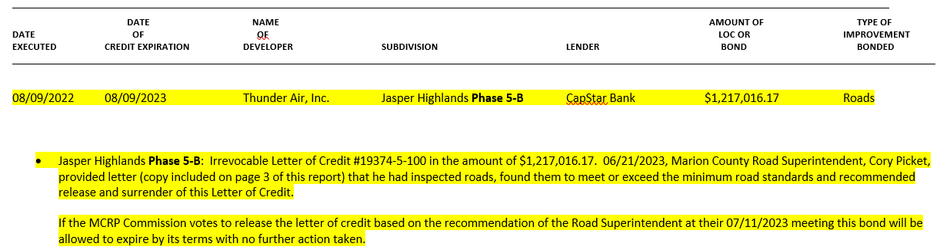

Release of Letter of Credit

Motion By: Louise Powell
2nd: Gene Hargis
Vote: All MCRP members voting “Aye”

Marion County Planning Office
24 Courthouse Square
Suite 105
PO Box 789
Jasper, TN 37347
Phone 423 942 3527
E-Mail: rwilson@marioncountytn.net
Website: www.marioncountytn.net

July 13, 2023

Dani Long, Portfolio Manager
P O Box 869
Athens, TN 37371

Re: Irrevocable Letter of Credit: #19374-5-100
In the amount of: $1,217,016.17
Dated: August 9, 2022
For: Jasper Highlands Phase 5-B
Issued on behalf of: Thunder Air, Inc.
210 Battlecreek Road
South Pittsburg, TN 37380

This letter is to inform you that at the Marion County Regional Planning Commission meeting July 11, 2023, they were informed that Marion County Road Superintendent Cory Pickett had inspected the roads in Jasper Highlands Phase 5-B covered under the above referenced Letter of Credit. Since the roads were inspected and approved, the Planning Commission voted to release the above referenced Letter of Credit.

Therefore, on behalf on the Marion County Regional Planning Commission, please accept this letter, as a formal surrender of said Letter of Credit and a release of any claims that the Marion County Regional Planning Commission or Marion County, TN may have under said Irrevocable Letter of Credit #19374-5-100.

I have attached the original Letter of Credit marked void as requested.

Sincerely,

Renea Wilson
Planning Coordinator

cc: Mr. William Gouger, Marion County Attorney
Mr. David Jackson, Marion County Mayor
Mr. Cory Pickett, Marion County Road Superintendent
Mr. Dane Bradshaw, Thunder Air, Inc.

New Business

- Plat Title: Final Plat Hubbard Hollow Subdivision
Surveyor: Danny Dancy/Tennessee Valley Surveying
Property Owner(s): Kevin Hubbard
Property Address: Sequatchie Mountain Road
Parcel ID Number(s): 084 033.01
Analysis: This plat creates four lots which are accessed by an unimproved access easement which connects to Sequatchie Mountain Road.

Final Plat Approval

Subject to all signatures on all plat copies

Motion By: Jimmy Sneed
2nd: Louise Powell
Vote: All MCRP members voting “Aye”

- Plat Title: Preliminary Plat River Gorge Ranch
Phase 1 C
Lots 1283 - 1306
Surveyor: Jeff Elliott/Elliott Surveying
Property Owner(s): Thunder Air, Inc.

Preliminary Plat Approval

Motion By: Gene Hargis
2nd: Keith Garth
Vote: All MCRP members voting “Aye”

- Plat Title: Final Plat River Gorge Ranch
Phase 1 C
Lots 1283 - 1306
Surveyor: Jeff Elliott/Elliott Surveying
Property Owner(s): Thunder Air, Inc.

Grading and Drainage Plan
River Gorge Ranch Phase 1 B
Surveyor: Jeff Elliott/Elliott Surveying
Property Owner(s): Thunder Air, Inc.

Final Plat Approval

Subject to all signatures on all plat copies
Motion By: Louise Powell
2nd: Gene Hargis
Vote: All MCRP members voting “Aye”

- Profile STA 57 +00 to STA 105+00 TGR
River Gorge Ranch Phase 1 B
Surveyor: Jeff Elliott/Elliott Surveying
Property Owner(s): Thunder Air, Inc.

Approval
Motion By: Louise Powell
2nd: Keith Garth
Vote: All MCRP members voting “Aye”

- Plat Title: Final Plat River Gorge Ranch
Phase 1 B
Lots 1181 - 1185
Surveyor: Jeff Elliott/Elliott Surveying
Property Owner(s): Thunder Air, Inc.

Final Plat Approval

Subject to all signatures on all plat copies
Motion By: Jimmy Sneed
2nd: Commissioner Morrison
Vote: All MCRP members voting “Aye”

Other Discussion:

There was no further business to be presented or considered before this Commission, a motion was made to adjourn.

Motion By: Jimmy Sneed
2nd: Commissioner Morrison
Vote: All MCRP members voting “Aye”

