To: Marion County Regional Planning Commission and Marion County Planning Commission Files
From: Renea Wilson
Date: July 11, 2023
Subject: Minutes for the June 6, 2023, Marion County Regional Planning Commission
Meeting held at 4:00 P.M., at the Lawson Building

Members Present
Keith Garth
Gene Hargis, Marion County Commissioner, District 2, Seat B, Co-Chairman
Mayor David Jackson, Marion County Mayor, Chairman
Robert Kelly
Cory Pickett, Marion County Road Superintendent
Chris Morrison, Marion County Commissioner, District 5, Seat C
Louise Powell, Secretary
Johnny Rogers
Jimmy Sneed

Members Absent

Staff
Ashley Gates, Senior Regional Planner, SETDD, Chattanooga
William ‘Billy’ Gouger, Marion County Attorney

Others
Jeff Elliott/Elliott Surveying
Clarence Howard, SR. V.P. of Construction, Thunder Air Inc
Dane Bradshaw
Paul Schafer, Marion County Commissioner, District 3, Seat C

Mayor Jackson, called the regular monthly Marion County Planning Commission meeting to order at 4:00 P.M.

- Invocation Commissioner Hargis
- Pledge of Allegiance Commissioner Morrison
- Roll Call Renea Wilson

A motion was made to approve the May 2, 2023 Planning Commission Meeting Minutes as presented.

Motion By: Commissioner Hargis
2nd: Keith Garth
Vote: All MCRP members voting “Aye”

Old Business

Building Permit Report

May 2023
40 Permits issued – Value - $6,426,850.45
- six million four hundred twenty-six thousand eight hundred fifty dollars and forty-five cents

Staff Approved Plats Report

There were 4 Staff Approved Plats for May 2023

Irrevocable Letters of Credit and/or Bonds Report
There were no additions or revisions to this report since your last MCRP meeting May 2, 2023.

Call to your attention the following has a credit expiration date of 08/09/2023:
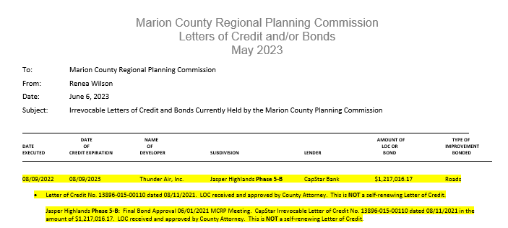

New Business

- Plat Title: Preliminary Plat River Gorge Ranch
Phase 1
Lots 1314-1 – 1317-6 & 1323-1 – 1323-7
Surveyor: Jeff Elliott/Elliott Surveying
Property Owner(s): Thunder Air, Inc.
Property Address: Musket Road/Cannon Way
Parcel ID Number(s): 129 005.01 & 005.02
Analysis: See below
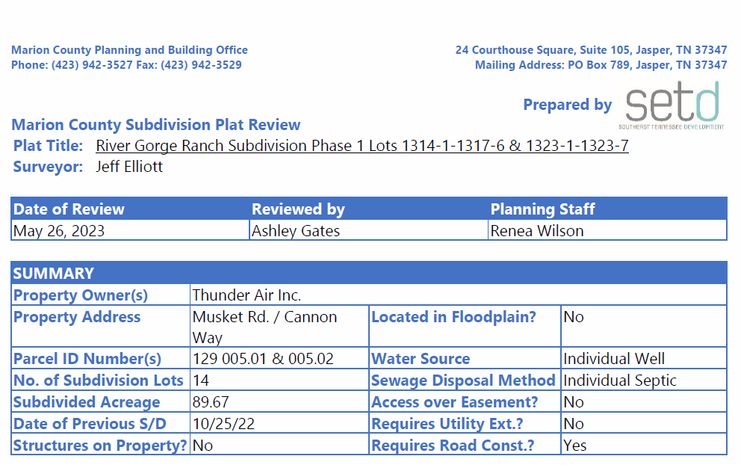

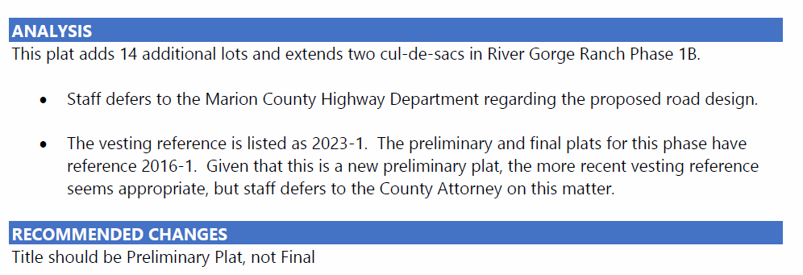

Surveyor, Jeff Elliott: Covers extending the road and making sure the bond covered it. Lots down here on the south end that we added. I had to separate them out from 1-B make them a separate section.

Ashley Gates: Plat should say Preliminary in all locations on the plat. That needs to be adjusted.

Attorney Gouger: It says Preliminary here but in the legend in the bottom right corner it says Final. It has the Preliminary certificate below the heading at the top but the legend at the bottom still says final. Not a significant issue if he (Surveyor, Jeff Elliott) just lines thru it and writes in Preliminary, dates and initials.

Ashley Gates: With the change of the word Final to Preliminary assuming Mr. Pickett is o.k. with the Road Design then this would meet their standards.

Road Superintendent, Cory Pickett: I went out there and looked and it’s good.

Preliminary Plat Approval

Subject to modification by the surveyor of the plat title by lining out Final Plat
and writing in Preliminary Plat initialing and dating the change. This modification
must be made in the lower right corner of the plat on all pages of each plat copy.

Motion By: Cory Pickett
2nd: Louise Powell
Vote: All MCRP members voting “Aye”

- Plat Title: Final Plat River Gorge Ranch
Phase 1
Lots 1314-1 – 1317-6 & 1323-1 – 1323-7
Surveyor: Jeff Elliott/Elliott Surveying
Property Owner(s): Thunder Air, Inc.
Property Address: Musket Road/Cannon Way
Parcel ID Number(s): 129 005.01 & 005.02
Analysis: See below
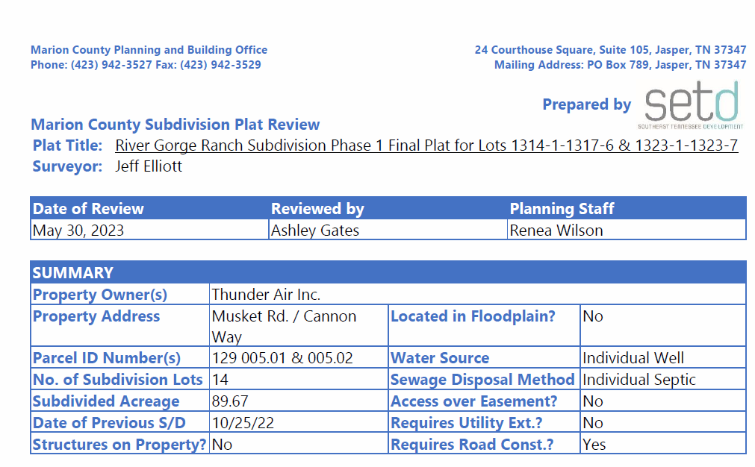
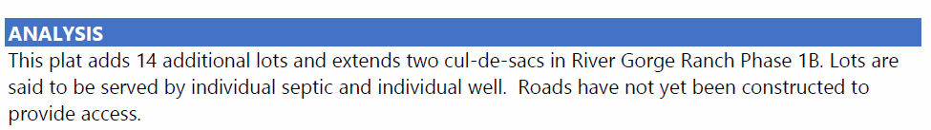

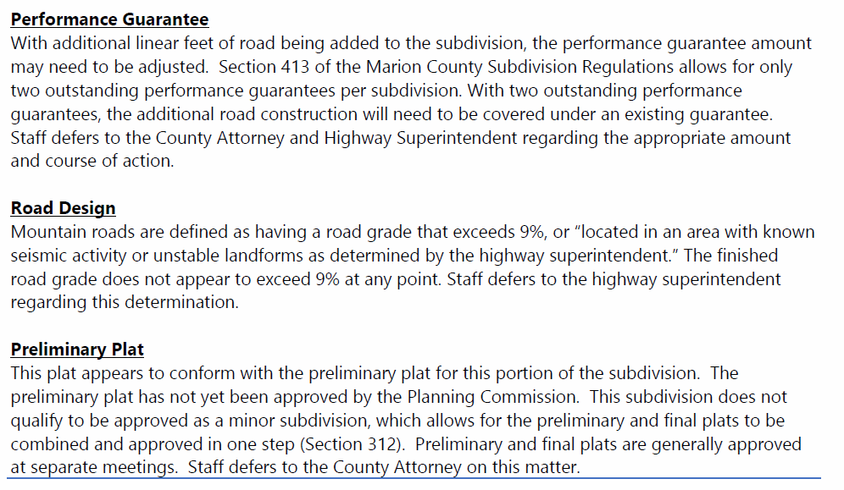

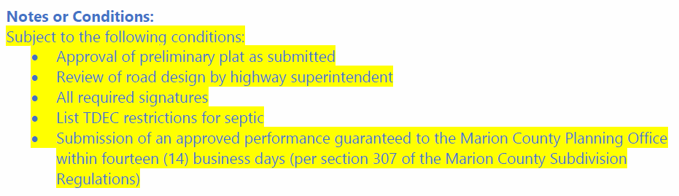

Final Plat Approval

Subject to soil approvals with signatures being added and all signatures on all plat copies.

Motion By: Louise Powell
2nd: Keith Garth
Vote: All MCRP members voting “Aye”

- Plat Title: Preliminary Plat River Gorge Ranch
Phase 2
Lots 2001 - 2609
Surveyor: Jeff Elliott/Elliott Surveying
Property Owner(s): Thunder Air, Inc.
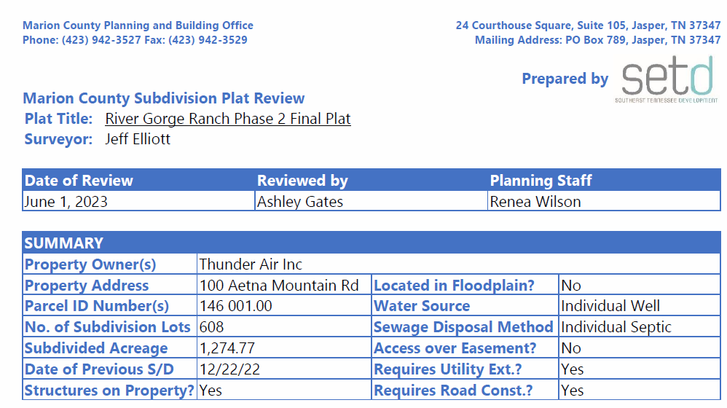

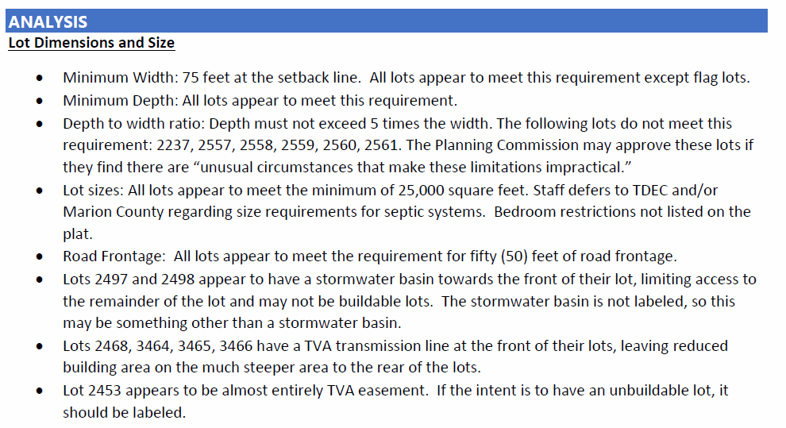
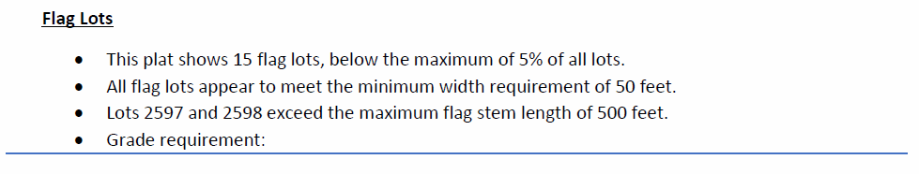
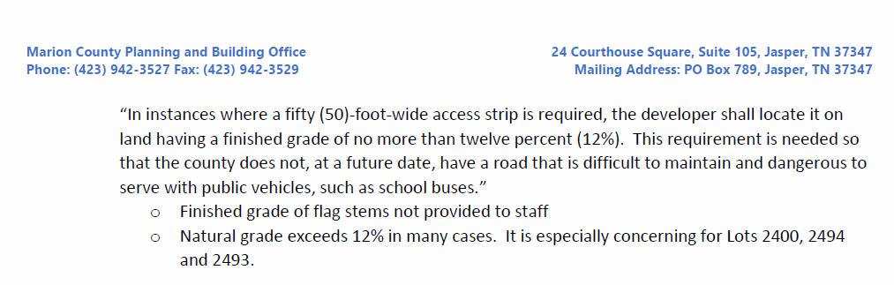
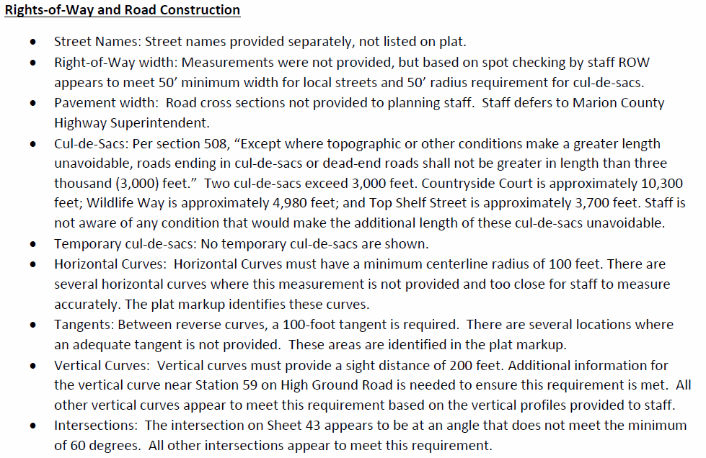
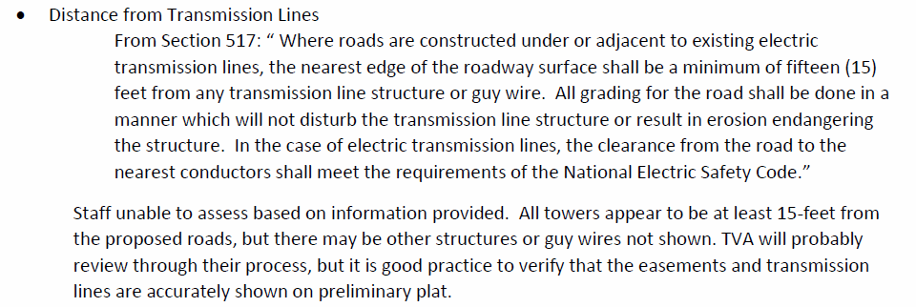
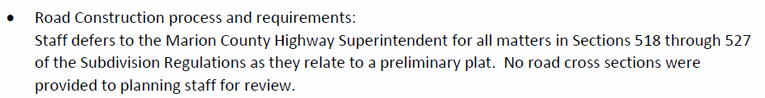
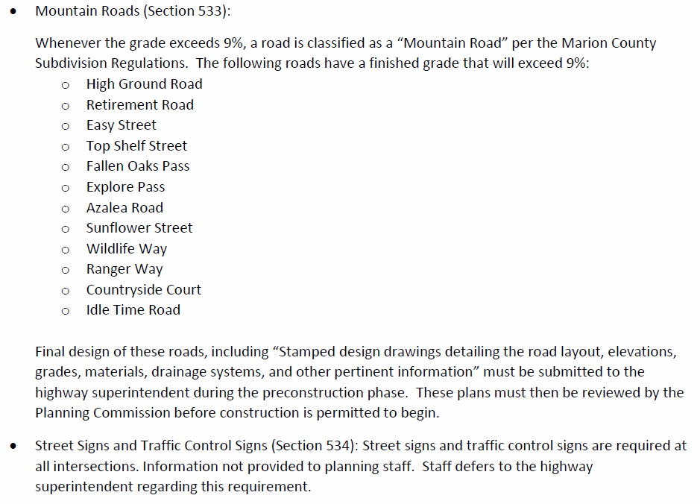

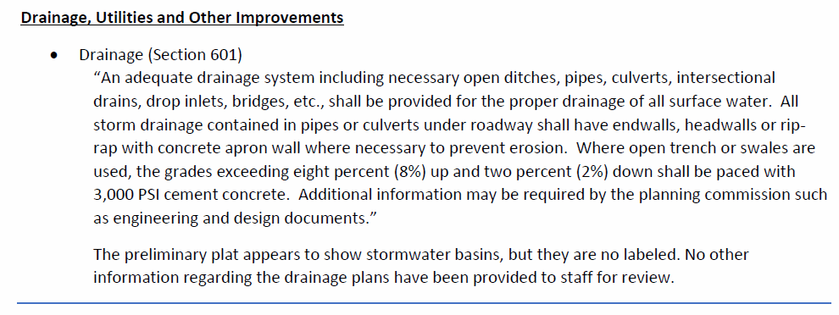
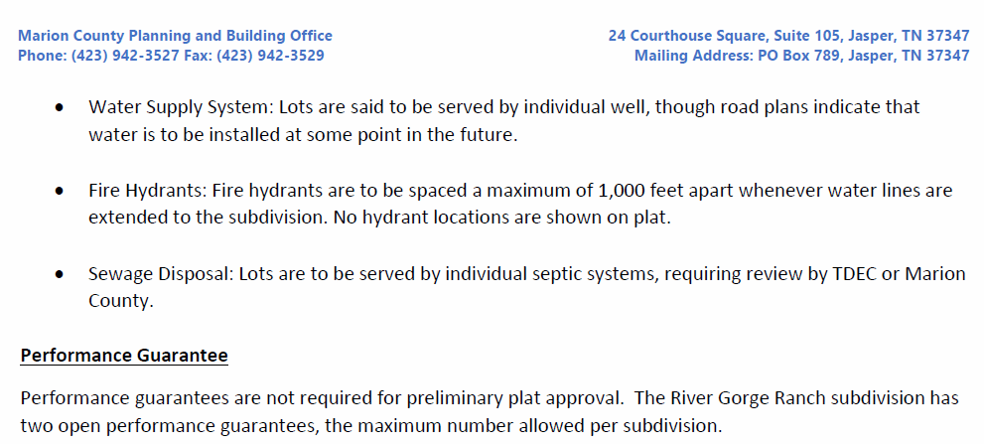

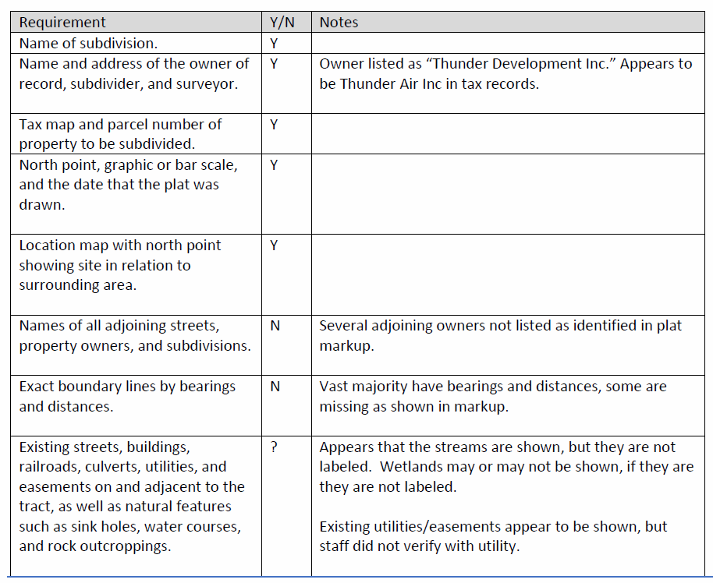
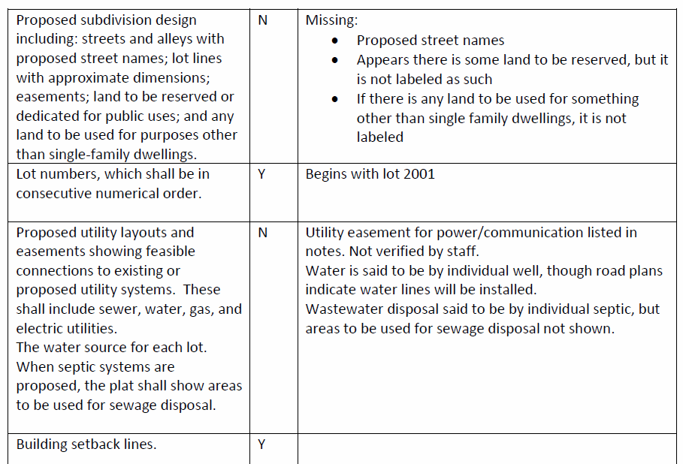
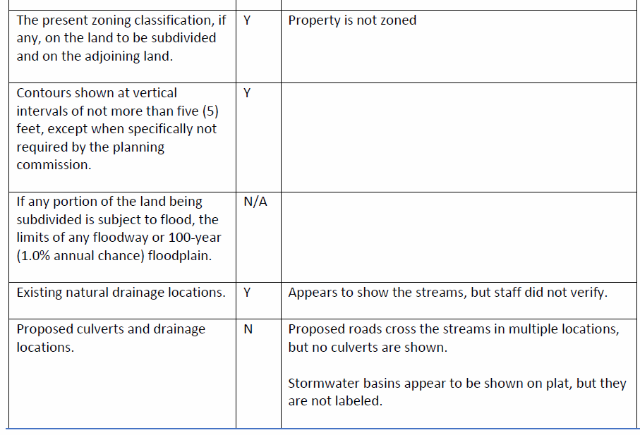

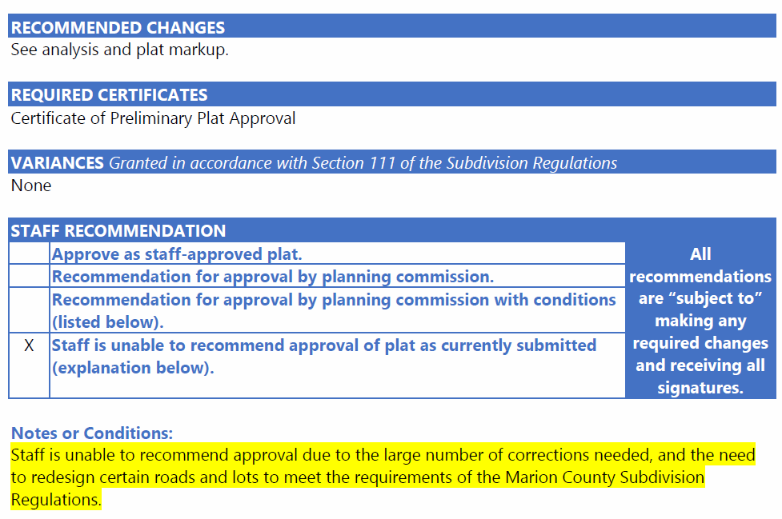

Attorney Gouger: 608 lots.

Surveyor, Jeff Elliott: Ashley wants corrections on part of the tangents and everything but in Phase 1 there are a bunch of tangents that weren’t over 100’ and they never were brought up.

Ashley Gates: I will go back and look at my review of Phase 1, but these roads are much more winding then Phase 1.

Surveyor, Jeff Elliott: Just keeps traffic slower.

Ashley Gates: I am just going by the standards of the County. I have had no chance to review any of your (Surveyor, Jeff Elliott’s) corrections.

My major concerns are:

- There are several reverse curves where there is not 100’ tangent. That’s where it’s making an S curve and there is not a long enough piece of road in between as required by your Subdivision Regulations.
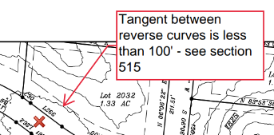

- Countryside Court is nearly 2 miles (10,300-foot-long cul-de-sac) and the maximum in your Subdivision Regulations is 3000 feet unless there are topographic or other conditions that make a shorter cul-de-sac impractical. So, you would have to make that finding here today if this commission wants to approve a 2-mile cul-de-sac.
Two others are also exceeded, that but by not nearly as much. Those are Top Shelf and Wildlife Way.
- The Flag Lots, 3 Flag Lots that exceed the 500’ foot maximum flag stem and some are located on very steep slopes and the maximum finished grade (we don’t have the finished grade available to us at this time) but it’s suppose to the 12%. A few of them are measuring over a 30% slope so I felt it might be difficult to meet that 12% requirement on flag lots and that your driveway going down to the road.
- Roads that cross streams at several locations, but no culverts are shown but he (Surveyor, Jeff Elliott) has stated that he has added those.
- There are other concerns there is one intersection on sheet 43 where the angle appeared to be too narrow. You have a 60%-degree requirement for those angles.
- There are horizontal curves where the measurement is not provided and is to close for staff to measure accurately to confirm that they met the standards. He (Surveyor, Jeff Elliott) says that he has made that fix.
- There are several lots I felt might be concerning to the Planning Commission. 2468, 2464, 2465 and 2466 have the TVA easement at the front of the property right where the road is. The easement comes along the road and then you can only build on the very back steep portion of those lots. I thought the Planning Commission might wish to specifically look at those lots and make a decision.
2497 and 2498 were two that have a similar situation, but I believe it’s a Storm Water basin along the right of way at the front of the lot which be even more difficult to cross with a driveway.
- Information about the culverts. I would suggest Road Superintendent, Cory Picket, review this. Your requirements call for 3,000 PSI cement concrete for your drainage for any slopes over a certain percentage and would be required in certain areas of this development. This falls under the Road Superintendent to review.
- To point out for the next Phase before road construction begins when I looked at the profiles there are several (12) roads exceeding 9% grade in certain spots that would require, and I quote from your Subdivision Regulations so that you are aware. Stamped Design drawings detailing the road layout, elevations, grades, materials, drainage systems and other pertinent information must be submitted to the Highway Superintendent during pre-construction phase
and then they must be revised by the Planning Commission on recommendation by the Highway Superintendent before construction is permitted to being.

Attorney Gouger: This is a Preliminary Plat. This is not the Final Plat so some of these concerns will be addressed between Preliminary and Final and there probably will be some changes going forward. For example, that lot that is completely unbuildable they may decide to do something different with that lot between now and the time the Final Plat is brought to you.
Cory (Road Superintendent) so you say they have already submitted the Road Plans to you, and you have those now?

Road Superintendent, Cory Pickett: Yes. I went up there and checked everything out on the Phase 1-B and all that. Musket Road and Canon Way and did all that. I took a ride on about all of them.

Attorney Gouger: You have the plans for those already?

Road Superintendent, Cory Pickett: Yes, Jeff brought them by (the profiles).

Attorney Gouger: Clarence, are those the ones you told me that engineering had already been done on them?

Clarence Howard: Ya. We’ve got permit review there will be some stuff worked out with TDEC.

Attorney Gouger: So those when finalized will be submitted to the Road Superintendents office and they would review and approve those and then on the roads that are going to be exceeding the 9% grade would first be approved by Road Superintendent Pickett and then brought back to you as a body to approve. This would be a part of the Final Plat approval process.

Attorney Gouger: So, Dane even though the Preliminary Plat is 608 lots when you come back for Final Plat approval you are going to do it in phases like you did with Phase 1?

Dane Bradshaw: Correct. Obviously, similarly with the soils and Road Bond it’s pretty hard to bond all 608 lots before you can actually sell 608 lots. So, we would do it similarly

Preliminary Plat Approval

Commissioner Hargis: Cory, will you have time to go out there and look at these before theses (roads) next meeting?

Road Superintendent, Cory Pickett: Yes. It probably won’t be this week but in the next couple of weeks.

Attorney Gouger: When do you anticipate coming back with your first phase (Phase 2-A) Final Plat request?

Dane Bradshaw: Our goal would be next month. That might be aggressive but that’s what we would like to do.

Attorney Gouger: As part of that it would be the combining of the two existing Letter of Credits for RGR Phase 1 into one. The Planning Commission would have to either release one or both of these Letters of Credit and then you would substitute a new Letter of Credit in the place of the two that would be for the combined amount of those two.

Dane Bradshaw: When I talked to our bank, they said we would have a simultaneous (you guys would release the two Letters of Credit and) they would replace that with one large Letter of Credit.

Then obviously for us to plat any lots in Phase 2 it would be subject to a Letter of Credit for those specific lots we are plating. As we add more lots we would add more to the Letter of Credit.

It’s a little bit more paperwork for us to do it but obviously it our goal to make sure the County is covered for all outstanding roads.

Attorney Gouger: At end of the day from the County’s perspective, from a legal perspective for the County it doesn’t matter if it’s in multiple Letters of Credit or one Letter of Credit so long as the amount is sufficient to cover the calculated cost of building the roads and of course the buffer that the regulations have built in them.
I know there may still be some lingering confusion. Under our old regulations those kinds of improvements had to be done within a maximum of two years. But when the state passed the vesting laws that all went away. There was nothing that ya’ll did locally other than follow the state law which basically now allows longer periods of time of developers to be able to complete the development. As a result of that your Letter of Credit and your Subdivision Bonds no longer have an automatically built in deadline expiration date.

Most of them are written to be self-renewing and the only way they don’t renew annually is if you get a notice from the financial institution (it’s usually at least 60 days in advance) that they are not going to renew it, that gives you plenty of time to react to get something in it’s place before it expires. Worst case scenario that you can’t get anything in it’s place you can always call that Letter of Credit in before it expires. So, you have complete control over that so were as before you really didn’t.

Attorney Gouger: You still have some changes to this Preliminary Plat made Ashley, correct?

Ashley Gates: At a minimum I need the Planning Commissions direction as to which way they want to go. If they want to look at the 100’ tangents not being provided on these curvier roads, that 2-mile cul-de-sac (which would require a variance). Also, the 5 lots exceeding the 500’ foot maximum flag stem (which would require a variance) not just an approval.

Attorney Gouger: What the regulations would prefer that the commission find is that that road (2-mile cul-de-sac) that this road as designed, and the length of the cul-de-sac is unavoidable due to the topography.
If it’s too steep to go from where the cul-de-sac is planned to end to connect it to another planned road then that makes sense. As it is currently designed that changing it is really unavoidable because of the terrain they don’t have the ability to connect it to another planned road.

Combined Variance Approval

Grant all Variances in one motion: 1) 100’ tangents not being provided on those curvier roads 2) 2-mile cul-de-sac, 3) 5 lots exceeding 500’ foot maximum flag stem

Variance Motion By: Commissioner Hargis
2nd: Louise Powell
Vote: All MCRP members voting “Aye”

Preliminary Plat Approval
Motion By: Louise Powell
2nd: Commissioner Morrison
Vote: All MCRP members voting “Aye”

Other Discussion:

Dane Bradshaw: There are currently two Letters of Credit outstanding for RGR. Obviously when we went to plat Phase 1 initially the intent was to have it all as Phase 1 but we have had to do it in segments because of soil testing permits and that sort of thing. So, our plan has been to combine our two letters of credit into one that would cover all of Phase 1 which would take care of that objection in my mind.

So, we would have a Phase 1 Letter of Credit reissued from our bank to cover all of the existing Phase 1. The essentially, we would do the same thing we’ve done here with Phase 1 for Phase 2. Where we would of half of Phase 2 under a Letter of Credit and then as we go got to the end of Phase 2 we would make it one larger Letter of Credit as well.

Mayor Jackson: Suggested the July meeting scheduled for July 4, 2023 be moved to July 11, 2023 with the 4th being the Fourth of July holiday. This commission agreed. Mayor Jackson asked that Renea contact Denise Mason in his office to have the Public Notice Meeting Notice posted in the Chattanooga Times.

There was no further business to be presented or considered before this Commission, a motion was made to adjourn.

Motion By: Commissioner Morrison
2nd: Johnny Rogers
Vote: All MCRP members voting “Aye”

