To: Marion County Regional Planning Commission and Marion County Planning Commission Files
From: Renea Wilson
Date: March 12, 2024
Subject: Minutes for the February 6, 2024, Marion County Regional Planning Commission
Meeting held at 4:00 P.M., at the Lawson Building

Members Present
Keith Garth
Mayor David Jackson, Marion County Mayor, Chairman
Robert Kelly
Chris Morrison, Marion County Commissioner, District 5, Seat C
Cory Pickett, Marion County Road Superintendent
Louise Powell, Secretary
Johnny Rogers
Jimmy Sneed

Members Absent
Gene Hargis, Marion County Commissioner, District 2, Seat B, Co-Chairman

Staff
Ashley Gates, Senior Regional Planner, SETDD, Chattanooga
William ‘Billy’ Gouger, Marion County Attorney

Other’s Present:
Surveyor: Jeff Elliott/Elliott Surveying
- Clarence Howard, SR. V.P. of Construction, Thunder Air Inc

Paul Schafer, Marion County Commissioner, District 3, Seat C
June Schafer
Ruric Brandt, Marion County Commissioner, District 1, Seat A
Ronnie Kennedy

Mayor Jackson, called the regular monthly Marion County Planning Commission meeting to order at 4:00 P.M.

- Invocation Mayor Jackson
- Pledge of Allegiance Commissioner Morrison
- Roll Call Renea Wilson

A motion was made to approve the January 2, 2024 Planning Commission Meeting Minutes as presented.

Motion By: Cory Pickett
2nd: Keith Garth
Vote: All MCRP members voting “Aye”

Old Business

Building Permit Report

January 2024
32 Permits issued – Value - $4,533,033.23

- four million five hundred thirty-three thousand thirty-three dollars and twenty-three cents

NOTE: Currently as Building Permits are issued a Microsoft Works Database is used to collect data specific to that permit.
This database does not provide any functionality to produce any type reports or sort specific data. This database is used purely to manually enter the data and calculates the running total as entered in specific categories.

Staff Approved Plats Report

There were 1 Staff Approved Plat for January 2024

Irrevocable Letters of Credit and/or Bonds Report
There were no additions or revisions to this report since your last MCRP meeting January 2, 2024.

New Business

- Plat Title: River Gorge Ranch Phase 2 Final Plat Lots 2497 - 2608
Surveyor: Jeff Elliott/Elliott Surveying
Property Owner(s): Thunder Air Inc

Ashley Gates, Senior Regional Planner, SETDD, Chattanooga recommends MCRP approval subject to certain conditions:

- Review and recommendation of engineered road and drainage plans by Marion County Highway Superintendent
02/06/2024: Road Superintendent Cory Picket advised that he had reviewed these and that they are acceptable.

- Review of performance guarantee by Highway Superintendent and Marion County Attorney
02/06/2024: Attorney Gouger advised that with respect to the bond he had spoken with Road Superintendent Cory Pickett earlier today and that he (Cory) has looked at this plat and made some calculations based on the bonds that the county is holding for the roads themselves and he (Cory) felt like the amount was more than sufficient to cover the extension that this road would constitute.

- Drainage easements included as part of motion of approval or otherwise denoted in the manner recommended by the County Attorney
02/06/2024: Attorney Gouger advised that the only place we can put them now are in these meeting minutes since TDEC does not allow them to be put on the plat. With the approval by this MCRP to approve this plat these notes reflect that these lots are subject to drainage and utility easements along the lot lines.

- Corrections as listed in her review
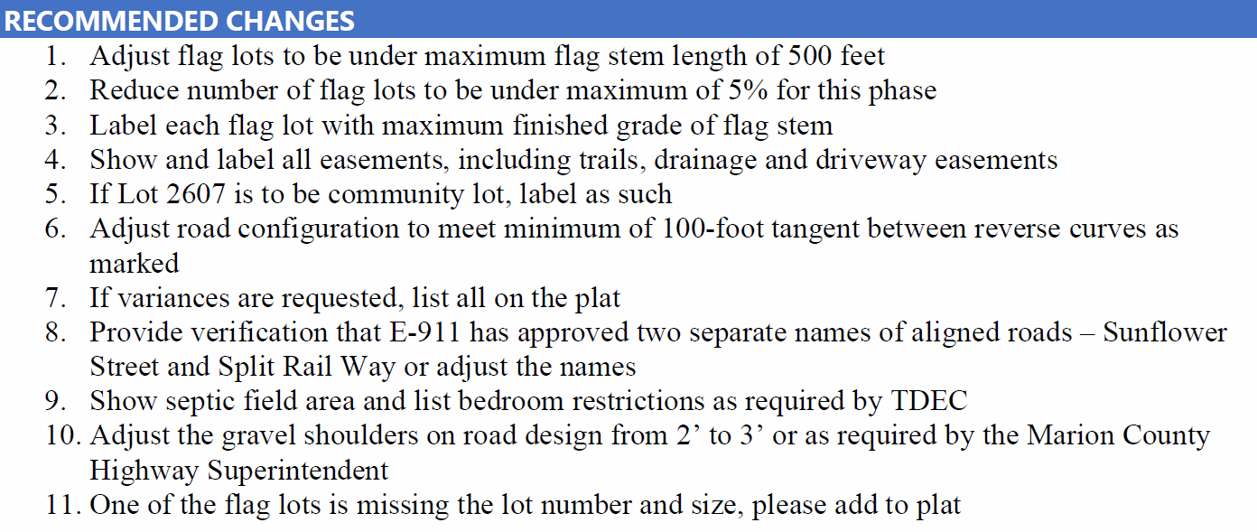

- All signatures

Variance 1
Lots 2596, 2597 and 2598 for the purpose of having 3 flag lots which exceeds the 5% of all lots in this phase.

Variance Approval
Motion By: Louise Powell
2nd: Commissioner Morrison
Vote: All MCRP members voting “Aye”
Variance 2
Allow Lots 2597 and 2598 to have a flag stem that exceeds 500 (five hundred) feet as necessitated by the topography.

Variance Approval
Motion By: Jimmy Sneed
2nd: Keith Garth
Vote: All MCRP members voting “Aye”

Variance 3
Allow Lots 2597 and 2598 to have a flag stem exceeding the 12% maximum grade.

Variance Approval
Motion By: Louise Powell
2nd: Johnny Rogers
Vote: All MCRP members voting “Aye”

Variance 4
For tangent sections 100 (one hundred) foot minimum between reverse curves.

Variance Approval
Motion By: Cory Pickett
2nd: Keith Garth
Vote: All MCRP members voting “Aye”

Variance 5
Lot 2513 allow acceptance of width and depth ratio.

Variance Approval
Motion By: Jimmy Sneed
2nd: Louise Powell
Vote: All MCRP members voting “Aye”

Final Plat Approval

Subject to all signatures on all plat copies and leaving the road name Split Rail Way on the entire length of the road and not Sunflower Street as had been shown.

Motion By: Louise Powell
2nd: Commissioner Morrison
Vote: All MCRP members voting “Aye”

Other
Mayor Jackson: Is there any public comment to anything that was on this meeting agenda only?

The next Marion County Regional Planning Commission meeting is Tuesday, March 12, 2024 since county offices are closed Tuesday, March 5th for Primary Elections.

Adjournment

There was no further business to be presented or considered before this Commission, a motion was made to adjourn.

Motion By: Johnny Rogers
2nd: Cory Pickett
Vote: All MCRP members voting “Aye”

